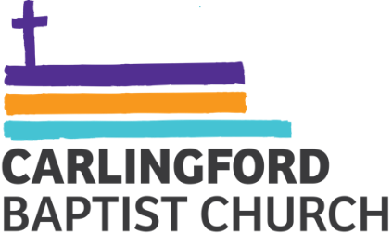

Health and Safety Rules
- Smoking is not permitted within all Carlingford Baptist Church buildings and outdoor areas on the sites known as Cnr of Alamien and Pennant Hills Rd, Carlingford.
- Alcohol and illegal drugs are not permitted within all Carlingford Baptist Church buildings and outdoor areas on the sites known as Cnr of Alamien and Pennant Hills Rd, Carlingford
- Food safety procedures as per ‘Food Preparation and Storage Guidelines’ are to be followed at all times (see Food Safety Procedures Manual in Kitchen)
- Do not undertake work for which you are not qualified.
- All hazards are to be reported to the Work Health & Safety Officer (preferably in writing on the Workplace Incident/Hazard Report Form) so that they can be addressed.
- Ministry leaders are responsible for leaving their ministry area in a clean and tidy state.
- All workers and volunteers should be aware of and observe the Emergency Evacuation Procedures.
- All workers and volunteers should be aware of and observe the Work Health and Safety policy.

